Week 1 (Monday – Tuesday)

Part 1: Computer Basics & Programming Concepts
Q1: A computer is an incredibly powerful machine, but it cannot directly understand or execute a file written in Java, C++, or Python. Why is this the case, and what does it understand instead?
- Answer: Computers are built on physical hardware circuits that can only process electrical states (on/off). Because of this structural design, a computer only understands binary language (machine code), which consists entirely of 0s and 1s. High-Level Languages (HLL) like Java, C++, and Python are designed to be human-readable and use English-like words, meaning the computer's CPU cannot execute them directly without translation.
Q2: What is the fundamental difference between an algorithm and a program?
- Answer: An algorithm is a logical, step-by-step plan or blueprint designed to solve a specific problem. It is independent of any programming language and can be written in plain text or drawn as a flowchart. A program, on the other hand, is the actual concrete implementation of that algorithm written in a specific high-level language (like Java) following strict syntax rules so a computer can eventually execute it.
Q3: Explain the concept of "sequential flow of execution" in a standard computer program.
- Answer: Sequential flow of execution means that the computer reads and runs the instructions in a program line by line, from top to bottom, in the exact order they are written. The computer will not skip lines or jump ahead unless explicitly given a specific instruction to change that flow.

Part 2: Hardware & Translation Mechanics
Q4: The CPU is often called the "brain" of the computer, while RAM is the primary memory. How do these two components work together when a program is running?
- Answer: The RAM (Memory) acts as a temporary, fast workspace that holds the instructions and data of the program currently being executed. The CPU fetches these instructions from the RAM one by one, decodes them, and performs the actual mathematical or logical calculations. RAM provides the data quickly, while the CPU does the active "thinking" and processing.
Q5: Describe the step-by-step translation process that a Java source code file goes through before it can be executed by a computer's hardware.
- Answer: 1. The developer writes the human-readable Source Code and saves it as a .java file. 2. The Compiler takes this source code and translates it into an intermediate, platform-independent format called Bytecode (a .class file). 3. The Java Virtual Machine (JVM) reads this Bytecode and interprets/translates it line by line into native Machine Code (binary), which the specific computer's CPU can finally understand and execute.

Q6: Why is Java considered a "portable" language, and which specific component makes this portability possible?
- Answer: Java is portable because of its "Write Once, Run Anywhere" nature. When Java code is compiled, it doesn't compile directly into a specific machine's binary code; instead, it compiles into universal Bytecode. This Bytecode can be carried to any operating system (Windows, Mac, Linux) and run instantly, provided that system has the Java Virtual Machine (JVM) installed to interpret it.

Part 3: Basic Java Syntax (print vs println)
Q7: What is the exact difference in behavior between using System.out.print() and System.out.println() in Java?
- Answer: System.out.print() displays the text on the console and leaves the output cursor right at the end of that text on the same line. System.out.println() displays the text and then automatically moves the output cursor down to the beginning of the next line. Any subsequent print statements will begin outputting from where the cursor was left.
Q8: If a developer is instructed not to use multiple print statements but still needs their console output to break into a new line halfway through a sentence, what tool should they use and how does it work?
- Answer: The developer should use the \n escape character (newline character) inside their text string. When the environment processes the string and hits \n, it treats it as a command to instantly drop the cursor down to a brand-new line before printing the remaining characters of that same string.

Part 4: Variables, Assignment, & Data Types
Q9: In programming, what is the distinct difference between variable "declaration" and variable "initialization"?
- Answer: * Declaration is the act of defining a variable for the first time by stating its data type and its name (e.g., int age;). This tells the computer to reserve a space in memory for it.
Initialization is the act of assigning a value to that declared variable for the very first time (e.g., age = 20;).
Q10: Explain why the line of code n = n + 5; makes perfect sense to a compiler, even though it looks mathematically impossible as an algebraic equation.
- Answer: In programming, the = symbol is not a mathematical sign of equality; it is the assignment operator. A computer handles this statement by evaluating the right side first: it takes the current value stored in the variable n and adds 5 to it. Once that calculation is done, it takes the final result and overwrites the old value of n on the left side with this new value.
Q11: Why does Java provide 8 distinct primitive data types instead of just using one single data type to hold all numbers and characters?

Answer: Java uses distinct primitive types to ensure memory efficiency and type safety. Different types of data require vastly different amounts of physical storage space in RAM (e.g., a tiny whole number takes much less space than a massive decimal number).

Part 1: String Concatenation & Type Casting
Q1: In Java, the + operator is used for adding numbers, but it behaves differently when a String is involved. What is this behavior called, and what happens when you execute System.out.println("The number is " + 5);?
- Answer: This behavior is called String concatenation. When the + operator is used between a String and any other data type (like the integer 5), Java performs implicit type casting. It automatically converts the integer 5 into a String counterpart ("5") and glues the two pieces together, resulting in the single combined text output: "The number is 5".
Q2: Predict the exact output of the following statement and explain the internal order of evaluation: System.out.println(5 + 5 + "Hello");
- Answer: The exact output is 10Hello. Java evaluates mathematical expressions from left to right. First, it encounters 5 + 5. Since both operands are integers, it performs standard arithmetic addition, which results in 10. Next, it evaluates 10 + "Hello". Because one of the operands is a String, Java switches to String concatenation, implicitly casting the number 10 into a String and merging it with "Hello".
Q3: Based on the left-to-right evaluation rule, how would the output change if the expression was rewritten as System.out.println("Hello" + 5 + 5);?
- Answer: The output would change to Hello55. Moving left to right, Java first evaluates "Hello" + 5. Because the first item is a String, it immediately performs concatenation, turning it into the temporary String "Hello5". Then, it evaluates "Hello5" + 5. Once again, because it is dealing with a String on the left, it performs concatenation a second time, attaching the final 5 to the end to produce "Hello55". No mathematical addition occurs.

Part 2: Constants & Modifiers
Q4: If a standard variable can have its value changed throughout a program, how can a developer create a variable whose value is permanently locked once assigned? What keyword is used?
- Answer: To create a permanent, unchangeable variable (a constant), a developer must use the final keyword when declaring it (e.g., final, int SPEED_LIMIT = 60;). Once a variable is declared as final and given an initial value, any subsequent attempt to modify or overwrite that value later in the code will cause a compilation error.
Q5: Why would a programmer intentionally use the final keyword to lock a variable's value instead of just using a regular variable and promising not to change it?
- Answer: Using the final keyword provides code safety and prevents accidental human errors. In large software projects, a developer (or a teammate) might unintentionally reassign a value to a variable that should never change (like the value of Pi, or a fixed tax rate). By using final, the compiler strictly enforces this rule and blocks the program from running if a dangerous change is attempted.

Part 3: Data Types & Literals
Q6: What is a "literal" in programming, and how does it differ from a variable?
- Answer: A literal is a fixed, concrete value written directly into the source code itself (for example, 100, 5.75, 'A', or "Hello"). It is the actual data. A variable, by contrast, is merely a named storage container in memory that holds a literal. In the statement int x = 25;, x is the variable, and 25 is the integer literal.
Q7: Java states that its 8 primitive data types take up "different spaces according to data types." Why is it fundamentally important for a computer to know the exact memory size requirements of a primitive type before a program runs?
- Answer: It is essential for memory management. Hardware RAM is finite. If Java allocated the exact same massive block of memory for a tiny number (like a true/false flag or the age of a person) as it did for a highly precise fractional decimal number, it would waste an enormous amount of physical memory space. Giving each primitive data type a fixed, distinct size allows the system to run efficiently without leaking or exhausting RAM.

Question to cover from this part (Initial 2 days):
Learning done : ?
- Every one should know what is class , classname , public , static , return type , main() ,String args[].
- Print Hello World / Possible uses of System.out.print().
- Variable practise ? Why we need to intialiase the variable in local scope . What are global and local variables. What are class variables , What are instance variable.
- Quotient , remainder problem . (Right use of operator , float division , integer division , modulo).
- Take input , and stdout on the screen problems. (Hackerank).
- Operators use , operator precedence table.
- Area and perimeter of the Circle.
- Celsius to Fahrenheit.
- Last Digit of Number.
- Find odd or even.

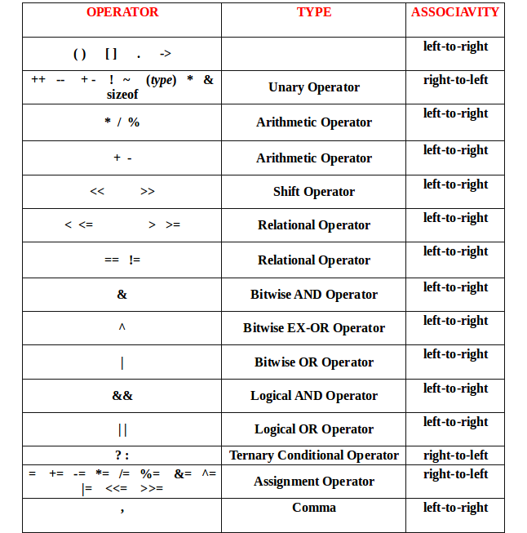

Week 1 , Wednesday-Thursday-Friday

Part 1: Relational & Logical Operators
Q1: Relational operators compare two values, but what is unique about the data type of their output? Provide a brief example.
- Answer: The output of a relational operator is always a boolean value (true or false). It can never return a number or text. For example, evaluating the expression 5 > 3 yields the boolean value true, while 10 == 2 yields false.
Q2: Explain the concept of "short-circuiting" in Java using the logical AND (&&) and logical OR (||) operators.
- Answer: Short-circuiting is an optimization where Java stops evaluating an expression as soon as the final outcome is guaranteed.
  - For &&, if the left side is false, the entire expression must be false, so Java skips evaluating the right side entirely.
  - For ||, if the left side is true, the entire expression must be true, so Java skips evaluating the right side.

Part 2: Conditionals (If, Else, Ladders, & Nesting)
Q3: Is it mandatory to always include an else block whenever you write an if statement in Java? Explain the relationship between the two.
- Answer: No, an else block is completely optional. An if statement can stand entirely on its own to execute code only when a condition is met. The else block simply provides an alternative path if the condition fails. If omitted and the if condition is false, the program simply skips the block and continues moving sequentially downward.
Q4: If a program has multiple independent if statements followed by a single else block at the bottom, how does Java decide which if the else belongs to?
- Answer: Java follows the rule that an else block is always associated with the nearest preceding if statement within the same block of code, unless curly braces {} are explicitly used to change the grouping.
Q5: What is an "if-else if-else ladder," and how does its execution mechanic differ from using multiple consecutive, individual if statements?
- Answer: In an if-else if-else ladder, the conditions are checked sequentially from top to bottom. The moment one condition evaluates to true, its corresponding block of code runs, and Java completely skips the rest of the entire ladder. Conversely, using multiple individual if statements forces the computer to check every single condition independently, even if the first one was already true.
Q6: What does the term "nesting of conditionals" mean, and when would a programmer need to use it?
- Answer: Nesting means placing an entire if or if-else block inside another if or else block. It is used when a second, deeper condition needs to be checked only after a primary condition has already passed.

Part 3: ASCII Table & Character Mechanics
Q7: Java allows you to compare characters using relational operators (e.g., 'a' < 'b'). How does the computer evaluate this comparison if it can only understand numbers?
- Answer: Computers use the ASCII Table (or Unicode), which assigns a distinct, unique integer value to every single character. When you compare characters like 'a' < 'b', Java looks up their underlying ASCII numerical values (where 'a' is 97 and 'b' is 98) and compares those numbers instead, evaluating 97 < 98 to true.
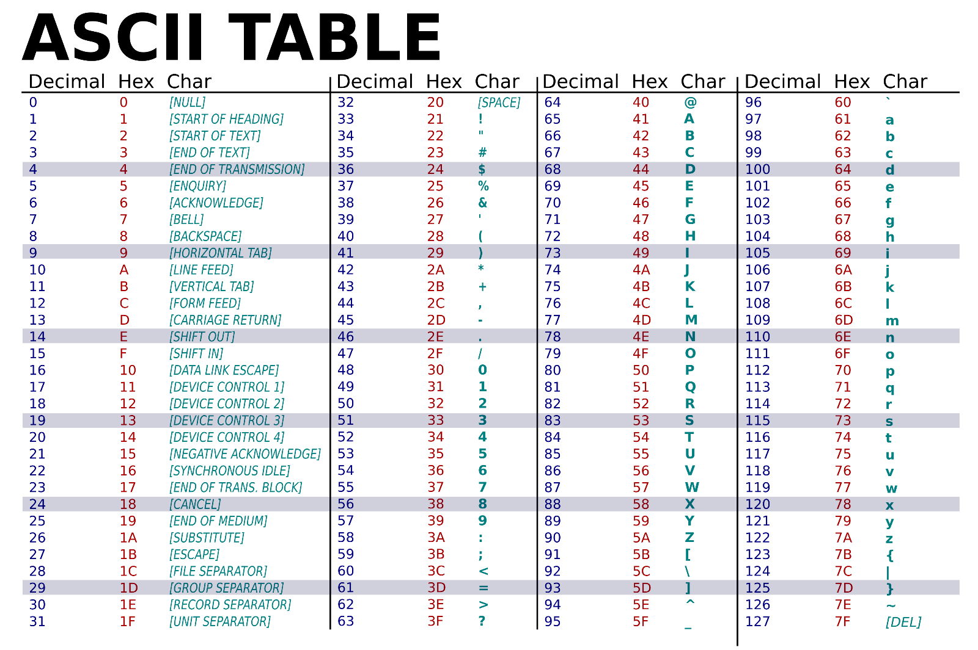

Part 4: The Need for Loops & Increment/Decrement Mechanics
Q8: Why do programming languages provide loop structures? What structural problem do they solve for a developer?
- Answer: Loops solve the problem of code duplication. Without loops, if a developer needs to repeat a specific task or block of code 100 times, they would have to copy and paste the same lines 100 times, making the file massive and hard to maintain. Loops allow a short block of code to execute repeatedly based on a condition.
Q9: Explain the structural difference and internal behavior of the following 4 variations of increment operations: i = i + 1, i += 1, i++, and ++i.
- Answer: * i = i + 1: The most explicit assignment. Evaluates i + 1 and overwrites i.
  - i += 1: The shorthand compound assignment version of i = i + 1. It behaves identically.
  - i++ (Post-increment): Uses the current value of i in the surrounding expression first, and then adds 1 to i afterward.
  - ++i (Pre-increment): Adds 1 to i first, and then uses this newly increased value in the surrounding expression.
Q10: What is a decrement operator, and how does its behavior change when transitioning from a post-decrement (i--) to a pre-decrement (--i) context?
- Answer: A decrement operator reduces a variable's value by 1. Just like increments, i-- uses the value first and then subtracts 1, whereas --i subtracts 1 first and then uses the updated value immediately.

Part 5: For Loop Mechanics & Problems
Q11: Describe the three distinct parts found inside the parentheses of a standard for loop header: for(part1; part2; part3).
- Answer: 1. Initialization (part1): Runs exactly once when the loop starts to declare and set up the loop control variable.
2. Condition (part2): Evaluated before every loop iteration. If true, the loop body runs; if false, the loop terminates.
3. Update (part3): Runs automatically at the very end of each iteration to alter the control variable before checking the condition again.
Q12: Write down the logical roadmap of a for loop designed to print the numbers from 1 to 10. How does the control variable change over time?
- Answer: The loop initializes a variable i = 1. Before printing, it checks if i <= 10. If true, it prints i. After printing, the update step runs (i++), turning i into 2. This sequence repeats until i becomes 11, causing the condition 11 <= 10 to fail, which exits the loop.
Q13: If you are asked to print all even numbers from 100 down to 0 sequentially using a for loop, how would you configure the initialization, condition, and update expressions?
- Answer: * Initialization: int i = 100; (Start at 100)
  - Condition: i >= 0; (Keep going downward until reaching 0)
  - Update: i -= 2; (Count backward by subtracting 2 each time to maintain even numbers)
Q14: Walk through the underlying logic required to find the sum of the first 10 natural numbers using a loop. What extra variable tracker do you need outside the loop?
- Answer: You need a tracking variable (e.g., int sum = 0;) declared before/outside the loop to accumulate the values. The loop runs from 1 to 10. During each iteration, the current loop counter value is added to the accumulator (sum = sum + i;). Once the loop terminates, sum holds the final total value.

Part 6: While Loop Mechanics & Problems
Q15: What is the fundamental structural difference between a while loop and a for loop?
- Answer: A for loop groups the initialization, condition, and update steps all together inside its header, making it ideal when you know exactly how many times the loop should run in advance. A while loop only takes a condition in its header; its initialization must happen before the loop, and its update must be written manually inside the loop body. It is ideal when the number of iterations is unknown beforehand.
Q16: How can you find the mathematical result of $A^B$ (Power of a Number) using a basic loop without using pre-built library functions?
- Answer: You create an accumulator variable initialized to 1 (int result = 1;). You then run a loop exactly B times. In every iteration, you multiply the accumulator by $A$ (result = result * A;). By the end of the loop, A will have been multiplied by itself exactly $B$ times.
Q17: Describe the logical algorithmic steps to extract and sum the individual digits of a multi-digit number (like 345) using a while loop and basic arithmetic operators.
- Answer: 1. Use the modulo operator % 10 to extract the very last digit of the number (345 % 10 = 5) and add it to a running sum.
2. Use integer division / 10 to chop off that last digit permanently (345 / 10 = 34).
3. Repeat this process inside a while (number > 0) loop until the entire number becomes 0.
Q18: If you are given a stream of numbers and want to isolate individual odd numbers inside a while loop, what mathematical condition do you evaluate?
- Answer: You check the number using the remainder operator: number % 2 != 0. If a number divided by 2 leaves a remainder that is not equal to 0, it means it cannot be evenly split by 2, identifying it as an odd number.

Part 7: Do-While Loops & Comparisons
Q19: What is the primary difference in execution behavior between a do-while loop and a standard while loop?
- Answer: A while loop evaluates its condition before running any code (pre-test loop); if the condition starts out false, the code block never runs. A do-while loop executes its code body first and checks the condition afterward (post-test loop). This guarantees that a do-while loop's body will always run at least once, no matter what.
Q20: Why is the do-while loop very rarely used by software developers compared to for and while loops?
- Answer: Most programming tasks require checking safety parameters or valid boundaries before performing an operation to prevent unexpected errors or processing bad data. Because do-while blindly executes its code once before evaluating anything, it naturally opens up more edge-case bugs, making for and while loops safer and cleaner choices for structural programming.

Part 8: Summarizing Loop Structures
Q21: Summarize the distinct ideal use case for each of the three loops: for, while, and do-while.
- Answer: for: Best when you know the exact number of iterations in advance (e.g., counting from 1 to 100).
  - while: Best when the loop depends on a dynamic condition and you don't know how many steps it will take to meet that condition (e.g., reading data until a specific stop flag is encountered).
  - do-while: Best when you absolutely need the operation to run at least once before verifying whether it needs to be repeated (e.g., presenting a text menu to a user).

Learning and questioning to cover :
1.Odd numbers b/w 1-10 using loops .
2. Sum of n natural numbers.
3. Factorial with loop.
4. Check prime.
5. Reverse digits of a number
6. Sum of digits
7. Palindrome Number.
8. Find GCD of given two number.
9.Armstrong numbers.
10. Number rotation.
11. Sum of natural number cubes
12. Count Squares
13. Fibonacii Series.
14. Factorial of a number

